How to Flash LIANUMPAD

1. Download QMK TOOLBOX, in this link <https://github.com/qmk/qmk_toolbox/releases>, adjust it to the OS you are using
2. Install QMK TOOLBOX and install all driver
3. Download File Hex
4. Insert file hex and check box Auto-Flash

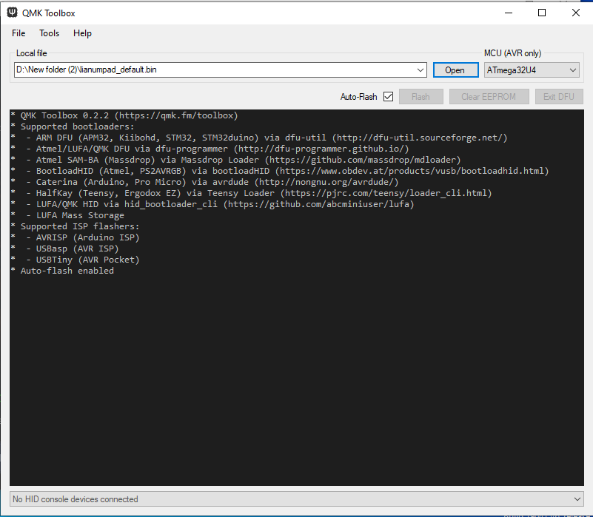

1. Pick your LIANUMPAD, press the button marked, then connect it to your PC's USB and immediately release the button
2. 
3. then there will be a sign that you have successfully flashed
4. If it fails, you can repeat the steps above